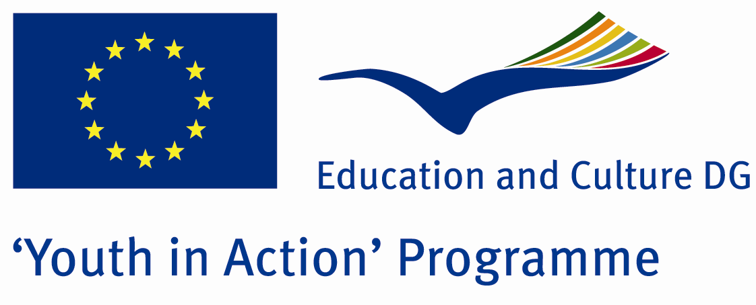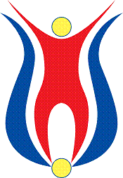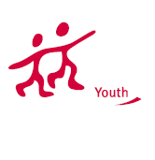

Action 1.1
Project Summary;

Do you live your life as healthy? Consider your opinion once more .When you join this project, you will see that this is not the situation at all and will take a step for a healthy life.
Project Title; Perfect Life
Date and Venue ; 22-29 April 2012,Turkey
Place: Kastamonu

Target Group ; Municipalities, City Councils and Non-Governmental organizations,
youth groups,culture and art groups,e.t.c

Participants ; 5 people from each country (over 18 -25 ). Totally 8 countries.

Conditions ; Accommodation, board and programme costs will be financed through European Commission Youth in Action Programme . Travel costs will be reimbursed in 70% (APEX Tarrifs). Organizations from all 27 EU member countries plus Liechtenstein , Norway and Iceland are eligible to take part.

Working language: English

Organisator group: Challenge Everythıng

How to apply: If you are interested, please send your Part III forms to
by e-mail please (in word file). Scan Part3 format is enough for application.(Fulfilled Part III which you can find in the attachment, of course signed and stamped) ..

Contact e-mail: groupchallengeeverything@gmail.com

